Project-1: ADDIE Model

Sermet Eser Özvataf, 135394

Eastern Mediterranean University  
Faculty of Education  
Department of Information and Communication Technologies in Education  
Instructional Design Theory and Application (ICTE501)

Submitted on 15/01/2014

Instructor: Asst. Prof. Dr. Ersun İşçioğlu

Project-1: ADDIE Model

Instruction design basically searches for the answers of “who-what-where-why-how” questions to setup a complete instruction system with the found answers. Therefore all components of instructional process is examined.

ADDIE model includes all processes between “what individuals need to learn” and “did individuals learn what they needed to learn” questions. This model has five phases named Analysis, Design, Development, Implementation and Evaluation. And its name is basically the acronym of these phases.

ADDIE phases usually combines and interacts between each other. In this context, ADDIE model provides a flexible roadmap to design efficient instructions.

There are three major questions in ADDIE model:

* Where do we want to go?
* How we got there?
* How we can know when we got there?

In ADDIE model, results of the each phases are also the inputs of to another one at the same time. An evaluation process at the end of the each phase decides whether iteration of next step is approvable or not.

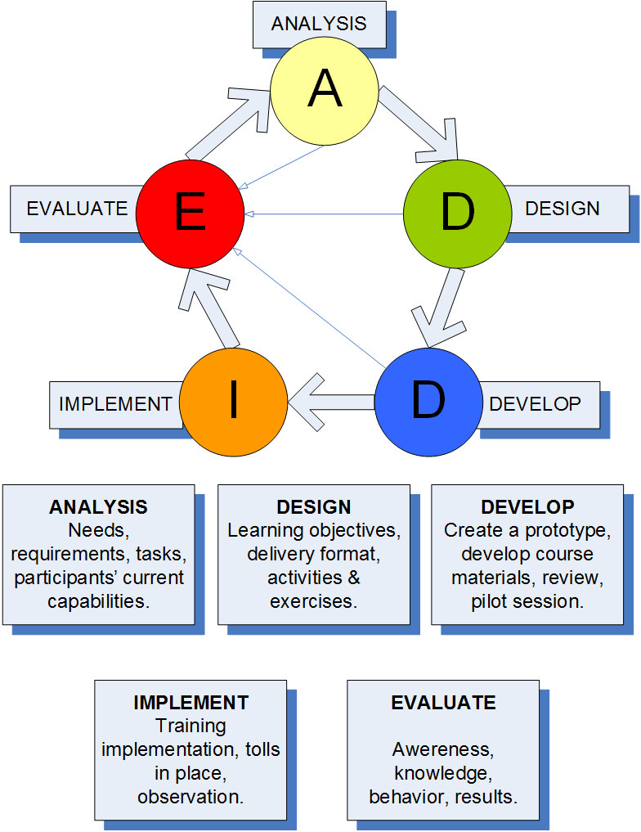

Figure 1

# Analysis

System gets analyzed to define the problem and problem source. Target audience, learning needs, goals, constraints and students current knowledge levels are considered in this step.

Questions of Analysis:

* How does your audience like to learn?
* What is the personality of your audience?
* What are your limits and capabilities regarding technology and personnel?
* What delivery methods (classroom, online, etc.) would be best to achieve the training objectives?
* Who will be delivering the training? What is the personality of the trainer?
* Are there any language or other obstacles to consider when designing the course?

# Design

Defines how to achieve goals. To accomplish it, choosing learning space, the design of the evaluation phase, instructional method and learning activities are done in this phase.

# Development

Instructional materials, all tools and support materials which will be used in education get produced in this phase. With the help of continuous evaluations, the final product may be changed before it presented to the individuals.

# Implementation

Where the final product meets with the individuals. After individuals begins to take the product, they also starts to give feedback.

# Evaluation

By gathering inputs from the other phases, evaluation phase controls whether goals are achieved or not. Since it is directly related to other phases of the model, it may roll back all the final product in order to fix the problem or improve the product if expectations are not satisfied.

References

http://hkaraoglu1020.blogspot.com/2013/03/ogretim-tasarmnda-addie-modeli.html

http://www.cimenwd.com/?p=124

Figures

Figure 1. A schematic figure of ADDIE model phases and their relations.